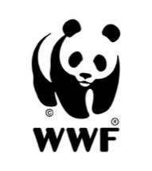
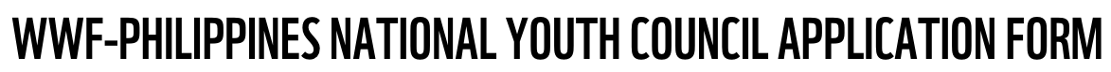
Batch 4: January 2024 – December 2026

PERSONAL IDENTIFICATION
FIRST NAME | FAMILY NAME | NICKNAME
PREFERRED PRONOUNS | NATIONALITY | DATE OF BIRTH

CONTACT INFORMATION

CURRENT ADDRESS
MOBILE NUMBER | EMAIL ADDRESS | LINK TO PUBLIC SOCIAL MEDIA ACCOUNT/S

CURRENT STATUS

FULL-TIME / PART-TIME STUDENT? | YES / NO
FULL-TIME / PART-TIME WORKER? | YES / NO
JOB POSITION
EMPLOYER

EDUCATION

NAME OF EDUCATIONAL INSTITUTION
LAST YEAR ATTENDED
AREA OF STUDY
PROGRAM OF STUDY INFORMATION
AFFILIATION (CLUBS, SCHOOLS, ORGS)
NOTABLE ACADEMIC ACHIEVEMENTS
OTHER EDUCATION / TRAINING

PLEASE ANSWER THE FOLLOWING QUESTIONS (MAX OF 150 WORDS PER QUESTION)

What is your particular area of interest that motivates you to apply to the National Youth Council?
What project/s would you propose to take up during your time in the council?
How do you think you will be able to contribute to WWF’s mission?
Describe work that you have done on environmental issues and what lessons have you learned from the experience?
Please share what you have done to communicate about your environmental advocacy/interests. Please share links to your sample work.

I certify that all statements in this application are true. I am also signifying my interest to be part of the National Youth Council of the Kabang Kalikasan ng Pilipinas Foundation Inc. (also known as WWF-Philippines).

_____________________________________ _____________________
Applicant’s name & signature Date

_____________________________________ _____________________
Parent’s name & signature Date
(if the applicant is under 18 years of age)

